* Last week:
  + the Internet’s service abstraction as a host-to-host datagram
  + Build on top of that: User Datagram
  + Reliable services on top of User Datagram: host, DNS, DHCP, … (idempotent short get)
  + TCP: convert datagrams to reliable byte streams
    - Sender Message: first_index, data, FIN
    - Receiver Message: next needed index, window size
    - “User Datagram” info (for multiplexing, and part of the TCP datagram port): source port (16 bits), destination port (16 bits), checksum
    - Internet datagram (v4): source address(32 bits), destination address (32 bits), checksum
    - source IP + source port + destination IP + destination port define a connection
    - There can be 2^32 * 2^16 * 2^16 simultaneous connections from one computer.
    - e.g. ByteStream: “abcdef”
      * Sender message: {first_index=0, data: “abcdef”, FIN=true}
      * Or {first_index=0, data=”abcdef”, FIN=false} and {first_index=6, data:””, FIN=true}
      * Receiver message: {next_needed=6, window_size=0}, {next_needed=6, window_size=3} (FIN flag also consumes a sequence number}, {next_needed=7, window_size=2}
      * Ordering of messages:
        + sender: {first_index=0, data=”abcdef”, FIN=false}
        + receiver: {next_needed=6, window_size=0}
        + After the reader pops 3 bytes: {next_needed=6, window_size=3}
        + sender: {first_index=6, data:””, FIN=true}
        + receiver: {first_index=6, data:””, FIN=true}
* What happens when a stream ends?
  + My sender has ended its outgoing bytestream, but the incoming bytestream from the peer may not be ended.
  + When a stream ends, can the same pair of ports be used? Reusing the same pair of ports makes it not clear to tell whether a datagram belongs to the old stream or the new stream.
  + We want a new INCARNATION of the connection (new connection on the same pair of ports)
  + **Sequence number**: start from a random big number + **SYN**: this sequence number should be viewed as the beginning of a stream
    - If the sequence number doesn’t make sense on the old stream, and the SYN flag is true, the receiver knows this is a new incarnation of the connection.
    - e.g. {sequnce_no=12345, data=”abcdef”, SYN=true, FIN=true}, and {sequence_no=99999, data=”xyz”, SYN=true, FIN=true}
  + First seqno belongs to SYN flag, next seqnos belong to each byte of stream, final seqno belongs to FIN flag.
    - It is very important to have SYN flag and FIN flag delivered reliably, so therefore receiver need to acknowledge SYN seqno and FIN seqno
* What happens to TCP receiver message’s next_needed_idx field before receiving the SYN flag from the peer?
  + Without seqno:
    - I: {{first_index=0, data=”abcdef”, FIN=true}, {next_needed=0, window_size=1000}}
    - Peer: {{first_index=0, data=””, FIN=true}, {next_needed=7, window_size=1000}}
    - I: {{first_index=7, data=””, FIN=false}, {next_needed=1, window_size=1000}}
  + With seqno and SYN:
    - I: {{seqno=12340, SYN=true, data=”abcdef”, FIN=true}, {**What should this be? (before seeing 9999 from the Peer**)}}
    - Peer: {{seqno=9999, SYN=true, data=””, FIN=true}, {next_needed=12348, window_size=1000}}
    - I: {{next_needed=10001, window size =1000}}
  + ackno = optional<int> (a pair of ACK flag and ackno int)
    - I: {{seqno=12340, SYN=true, data=”abcdef”, FIN=true}, {ACK=false, ackno={missing}, window_size=1000}} (SYN)
    - Peer: {{seqno=9999, SYN=true, data=””, FIN=true}, {ACK=true, ackno=12348, window_size=1000}} (SYN+ACK)
    - I: {{ACK=true, ackno=10001, window size =1000}} (ACK)
  + (SYN) + (SYN+ACK) + (ACK) = “the three-way handshake”
  + What if the two SYN messages are sent at the same time?
    - 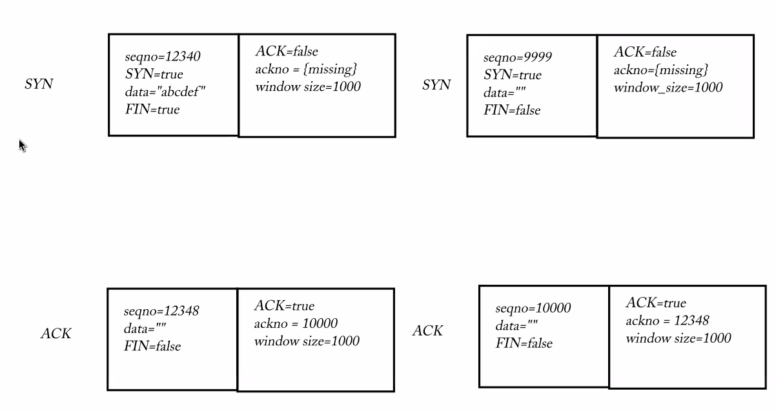
    - Not a classic “three-way handshake” but still a valid way of starting a TCP connection.
* Standardized TCP Message:
  + Sender: {sequence number, SYN, data, FIN}
  + Receiver: {ackno: optional<int>, window_size}
  + “User Datagram” info

<https://www.rfc-editor.org/rfc/rfc9293.html#name-header-format>

 0 1 2 3

0 1 2 3 4 5 6 7 8 9 0 1 2 3 4 5 6 7 8 9 0 1 2 3 4 5 6 7 8 9 0 1

+-+-+-+-+-+-+-+-+-+-+-+-+-+-+-+-+-+-+-+-+-+-+-+-+-+-+-+-+-+-+-+-+

| Source Port | Destination Port |

+-+-+-+-+-+-+-+-+-+-+-+-+-+-+-+-+-+-+-+-+-+-+-+-+-+-+-+-+-+-+-+-+

| Sequence Number |

+-+-+-+-+-+-+-+-+-+-+-+-+-+-+-+-+-+-+-+-+-+-+-+-+-+-+-+-+-+-+-+-+

| Acknowledgment Number |

+-+-+-+-+-+-+-+-+-+-+-+-+-+-+-+-+-+-+-+-+-+-+-+-+-+-+-+-+-+-+-+-+

| Data | |C|E|U|A|P|R|S|F| |

| Offset| Rsrvd |W|C|R|C|S|S|Y|I| Window |

| | |R|E|G|K|H|T|N|N| |

+-+-+-+-+-+-+-+-+-+-+-+-+-+-+-+-+-+-+-+-+-+-+-+-+-+-+-+-+-+-+-+-+

| Checksum | Urgent Pointer |

+-+-+-+-+-+-+-+-+-+-+-+-+-+-+-+-+-+-+-+-+-+-+-+-+-+-+-+-+-+-+-+-+

| [Options] |

+-+-+-+-+-+-+-+-+-+-+-+-+-+-+-+-+-+-+-+-+-+-+-+-+-+-+-+-+-+-+-+-+

| :

: Data :

: |

+-+-+-+-+-+-+-+-+-+-+-+-+-+-+-+-+-+-+-+-+-+-+-+-+-+-+-+-+-+-+-+-+

Note that one tick mark represents one bit position.



* Wireshark tool